Build a 360-degree customer view in AWS using a powerful set of analytics tools

Hugo Rozestraten and Andres Palacios

One of the challenges of digital transformation across companies is the task of consolidating customer data in one place, what we call a 360-degree customer view. This is a powerful concept in CRM (Customer Relationship Management) used on a daily basis on marketing, sales and customer services areas. Gather and aggregate information from heterogenous sources to build such view help us to have a complete vision of who are our customers, what are their preferences, what they have looked for, and how their preferences are correlated to other people preferences and behavior.

This implementation can be used to refine customer personas, their behavior and expectations, get to know touchpoints of interaction, perform a better post-sale service, cross-selling or up-selling, build personalized recommendation, map customer journey, and identify the gaps in channels or processes.

The common pain point is that information about customer is spread across several systems inside your company, from customer interaction with your call center records to events related to customer search behavior, you have several different data that are difficult to correlate if you don’t have a Data Lake strategy.

This blog post demonstrated how to bring data from different data systems as a set of customer dimensions and build a 360-degree customer view as a baseline for all customer analytics initiatives.

# Dimensions for a 360-degree customer view

Usually we look at our customers from a perspective, such as Loyalty perspective, looking at metrics like: years of history, frequency of interaction, or a Demographic perspective: stage of life, income, stage of life. We call them dimensions, and we will combine several dimensions about your customer to give you more visibility of several perspectives at the same time.

In this blog we will explore a hypothetic financial services company, as there are common dimensions for this industry and some dimensions that are also valid for any service industry, like marketing and communications, customer history or demographic dimension.

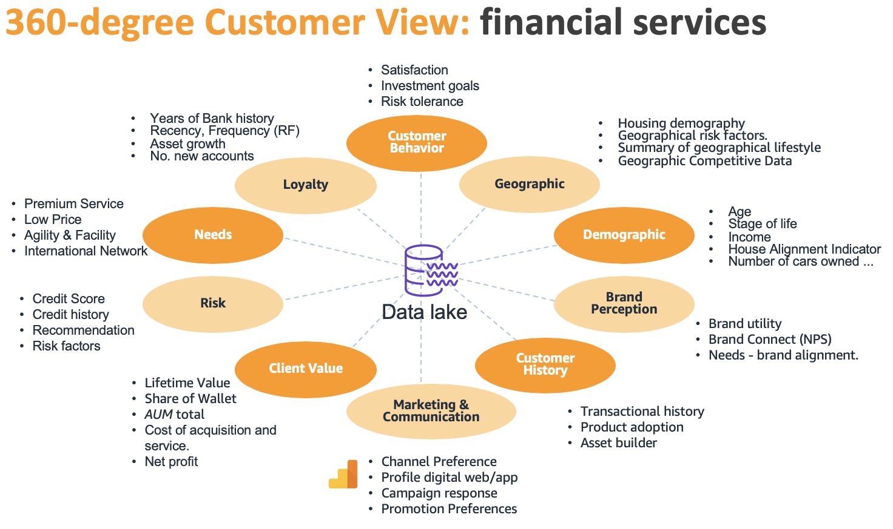

In the picture above we have list some of the dimensions, and the challenges we have to aggregate and use all this information is the number of different sources and formats.

For financial services we usually have a CRM (Customer Relationship Management) as a software as a service, that can be consumed by an API (Application Programming Interface) and provides JSON (JavaScript Object Notation) file format, Mainframe systems and some other systems that can be integrated by CSV (Comma-separated value) files, transactions from relational database generating thousands new records per minute and application logs or website navigation logs. New sources can come over time, like a new system or channel that are provided to customers.

# Data Lake strategy

Data lake is the source of truth, as a broad repository where we can put data from different systems and perform the cleaning, enrichment, aggregation, analysis to delivery relevant data to business users, about user behavior, assets, history, preferences and several other features.

To deliver summarized and at the same time comprehensive data about customer to business users and data scientists we need ingest data from the sources into a storage area and combine them to build a 360-degree customer view.

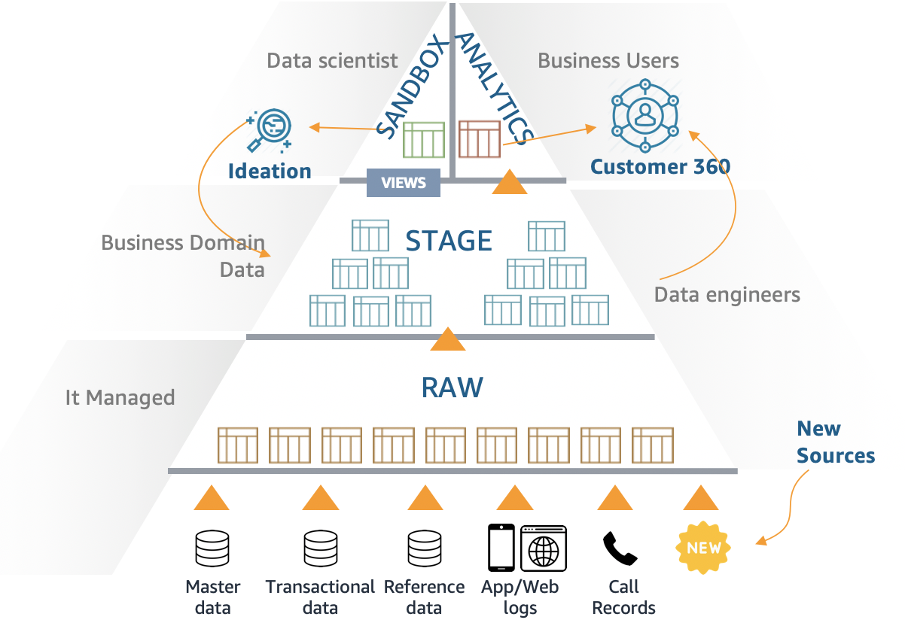

In a Data Lake we have some important tiers for the data and going from the bottom up, starting with data and ending up with strategic information for business decision:

* The **RAW** layer is the first storage area for data coming from several different sources and formats, usually the data in this area are in plain text (CSV) or JSON and in some cases, they are compressed files such as Gzip.
* **STAGE** is the storage area for the data we are handling, transforming and cleaning. In this layer we have control of the data format so we can storage the output in columnar formats such as Apache Parquet or Apache ORC compressed with Snappy that will have a better performance to join and aggregate data by columns or Apache Avro container files that has a JSON schema representation for each file.
* Finally, we deliver information to the **ANALYTICS** layer for the business areas ready for consumption and with good performance. To achieve this, we partition the data and use columnar formats to make it easy and fast to query data, filter it or aggregate it.
* In parallel, the **SANBOX** area is for the Data Scientists to interact with data from **STAGE** or even **ANALYTICS** data to build new data models, discover new correlations and build machine learning models.

So, the second challenge that comes is to have powerful analytics tools that can enrich, filter, clean and aggregate this data, analyze them and generate information. Also, the tools need to fit each of the needs for example Data Engineer transformation, from small to large volumes, a Data Scientist complex algorithm and a Business user query engine. There is no ‘*silver bullet’* in the market, the best product for one step or role is not the best for another, and AWS provides a broad variety of these tools.

# Data Lake in AWS

Data lake in AWS has a key storage component Amazon S3 that stores, secure and maintain data in a very cost-effective way and provides high throughput with the AWS ingestion and the analytics tools.

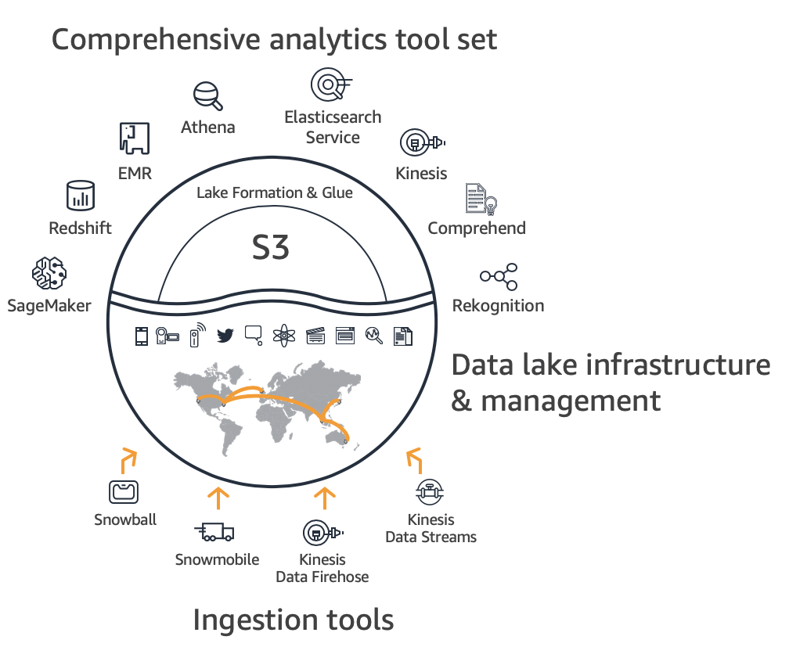

To ingest data into our data lake we can use [AWS Snowball](https://aws.amazon.com/snowball/?nc1=h_ls) to send large amount of files, [AWS Direct Connect](https://aws.amazon.com/directconnect/?nc1=h_ls) connection for high speed network data transfer, and services like [AWS DataSync](https://aws.amazon.com/datasync/?nc1=h_ls), [AWS Data Migration Service](https://aws.amazon.com/dms/?nc1=h_ls) and [AWS Transfer for SFTP](https://aws.amazon.com/sftp/?nc1=h_ls) for different needs to ingest data in our AWS data lake. Also [Amazon Kinesis Data Streams](https://aws.amazon.com/kinesis/data-streams/?nc1=h_ls) and [Amazon Kinesis Data Firehose](https://aws.amazon.com/kinesis/data-firehose/?nc1=h_ls) to ingest streaming data.

In this blog we are using [AWS Lake Formation](https://aws.amazon.com/lake-formation/?nc1=h_ls) blueprints and [AWS Lambda](https://aws.amazon.com/lambda/?nc1=h_ls) functions to extract data actively from some sources and APIs, and also [Amazon S3](https://aws.amazon.com/s3/?nc1=h_ls) direct put files from legacy systems.

To transform data we can use serverless fully managed [AWS Glue](https://aws.amazon.com/glue/?nc1=h_ls) jobs, a powerful and flexible Hadoop and Spark ecosystem [Amazon EMR](https://aws.amazon.com/emr/?nc1=h_ls), and small jobs and streaming processing with [AWS Lambda](https://aws.amazon.com/lambda/?nc1=h_ls) functions orchestrated by [AWS Step Functions](https://aws.amazon.com/step-functions/), and executed with lake [Amazon Athena](https://aws.amazon.com/athena/?nc1=h_ls) query engine, that also supports create new tables and insert data, we will explore uses cases for each of them in this blog.

[Amazon DynamoDB](https://aws.amazon.com/dynamodb/?nc1=h_ls) can be used to deliver data in a very low latency and scalable way, we are going to delivery consumable information about our customer for business users.

# Our 360-degree customer view approach

We suggest a final denormalized **customer 360 table** on top of the Data Lake that can be update on an hourly, daily or weekly basis depending the delta frequency of new data on the source tables and the business need. This final view will be generated from intermediate tables across several layers depending its degree of processing in all transformation steps using a bottom up approach. This tables can be named using a hierarchical naming convention to facilitate the data lineage, give a sense of hierarchy, allow the addition of new tables on the overall ETL orchestration process.

# Sample Data sources

The following picture represents common and heterogenous data sources from financial services customers we have used in this Blog, with synthetic data.

# 

Find in the table below the attributes for each data source we used:

|  |  |  |  |
| --- | --- | --- | --- |
| **Domain** | **Data source** | **Source Format** | **source column name** |
| Customer info | CRM | API - json | client_id |
| age |
| date_Of_Birth |
| home_ownserhip_status |
| occupation |
| marital_Status |
| head_of_household_flag |
| client_created_date |
|  |  |  |  |
| Transactions | Mainframe sources | Relational Database | trans_id |
| account_id |
| date |
| type |
| operation |
| amount |
| balance |
|  |  |  |  |
| Credit Card | Card origination system | Text file - from Mainframe | card_id |
| disp_id |
| type |
| issued_datetime |
|  |  |  |  |
| Account | Account origination system | Text file - from Mainframe | account_id |
| branch_ID |
| frequency |
| creation_date |
|  |  |  |  |
| General banking | Dispositions Database | Text file - from Mainframe | disp_id |
| client_id |
| account_id |
| type |
|  |  |  |  |
| web_analytics | Google Analytics | json with nested fields | client_id |
| visitNumber |
| visitId |
| visitStartTime |
| Date |
| Totals |
| trafficSource |
| device |
| geoNetwork |
| customDimensions |
| Hits |
| fullVisitorId |
| userId |
| WebVisitor map | Map web visitors to client_id | Text file | visitorId hash |
| client_id |

# Data processing

The picture represents from bottom to the top the data quality and filtering, aggregation and dimension calculations in order to create a final Customer 360 view which can be updated in a modular way by updating the dimension temporary tables (Level 3 ETL) to recreate the final table on a new partition.

# 

# Architecture overview

From the right left-hand side, we start with the sources, were we simulate a CRM API with two AWS Lambda functions one that act like an API generating the data an another to consume this API calling it and receiving and processing the result. We also have a relational database using Amazon RDS, we are using PostgreSQL as the engine, and finally we have flat files that commonly are generated by mainframe, in our cases we simulated the generation using AWS Lambda.



We use AWS Lake Formation blue prints to orchestrate the extraction from the relational database to Amazon S3, using AWS Glue connector and Glue jobs.

Then on the bottom we have the persistent layer on Amazon S3 the base for our Data lake strategy, with Raw, Stage and Analytics buckets.

For processing we are counting with Step Functions orchestrating AWS Lambda using Athena on the top, we also have AWS Glue Jobs, using Spark and Python, and Amazon EMR using Spark and Hive to transform and aggregate data.

To consume the data, we have Amazon Athena query engine console and API, and Amazon DynamoDB console and API.

All the code, sample data and deployment guide for the solution we used here are found in our [git repository](https://github.com/aws-samples/build-a-360-degree-customer-view-with-aws).

# Solution details

We created three buckets, one for each data purpose: raw data S3 bucket, stage data S3 bucket and analytics data S3 bucket.



All the data besides Google Analytics sample from Kaggle were synthetic created using lambda functions using random range values. You can use [Amazon AppFlow](https://aws.amazon.com/appflow/?nc1=h_ls) to extract your own data from Google Analytics data as described in this other [blog post](https://aws.amazon.com/pt/blogs/big-data/analyzing-google-analytics-data-with-amazon-appflow-and-amazon-athena/).

For the bank transactions we created a relational database Amazon RDS PostgreSQL.

To simulate the API we created Lambda function that responds as a CRM API, you can also use [Amazon AppFlow](https://aws.amazon.com/appflow/?nc1=h_ls) to extract data from your Salesforce environment.

For the mainframe simulation the lambdas generate flat files on Amazon S3.

We then used Amazon CloudWatch eventsschedules, to trigger the Lambda functions.

## Centralized control with AWS Lake Formation.

We use AWS Lake Formation to give permission to the data locations we created in Amazon S3 for the services roles that will read the data and create databases. We first register the locations as Data lake locations.



In the following picture we grant Glue-role-c360view IAM role access to the storage locations: raw, stage and analytics.



## Exploring raw data in Amazon S3.

Each data source has its path inside S3 to receive raw data.



Inside each folder we have data from one data source, for GA data for example its partitioned by date, with the pattern **data/GA/ga_session_YYYYMMDD**.



We can use S3 select to confirm the data we are receiving.

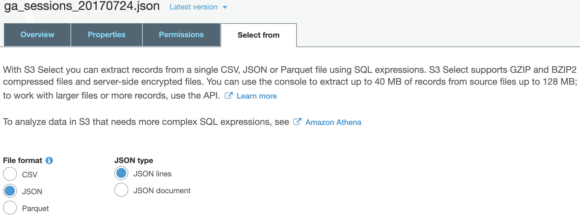

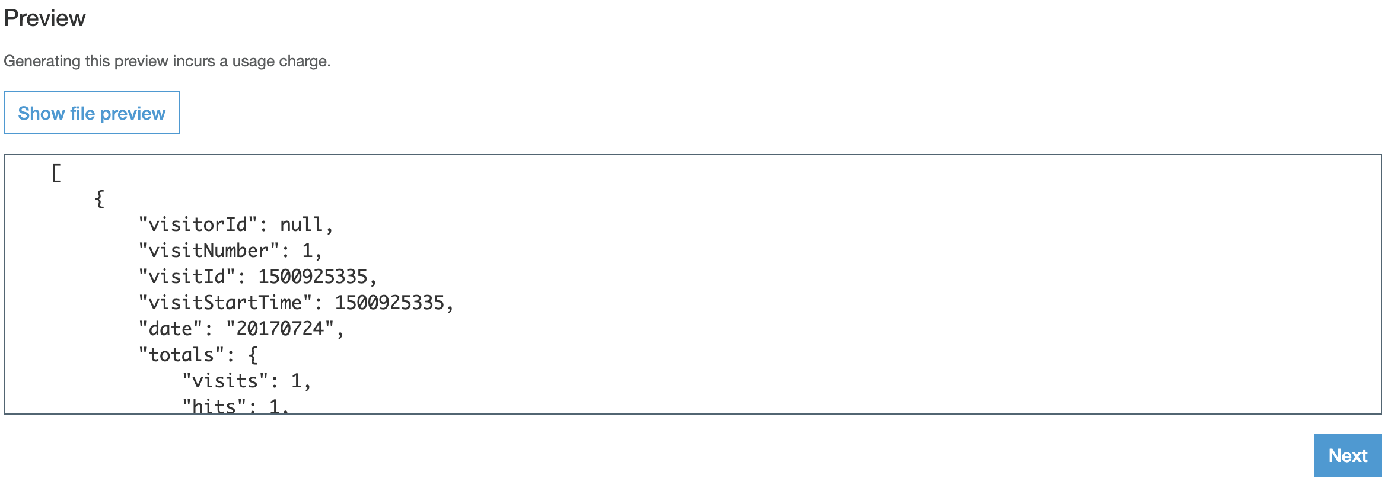

## Use AWS Lake Formation blueprint to load data from relational database

The banking transactions are in a RDBMS system and is loaded using an out-of-the-box blueprint from AWS Lake Formation.

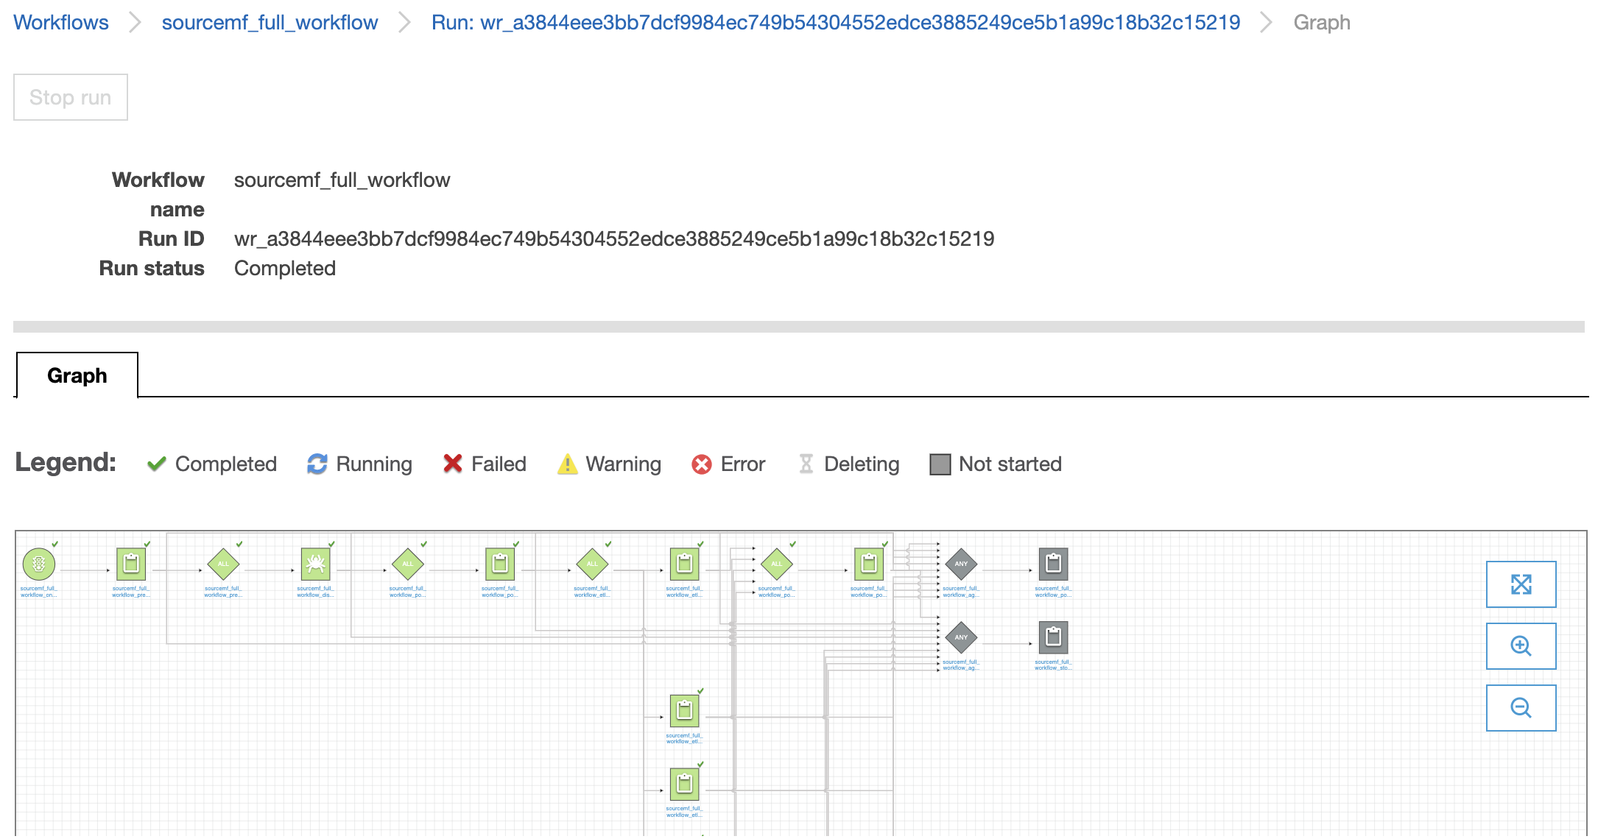

The relational database is crawled to pick tables definition then the data is loaded to an Amazon S3 folder for each table. This whole workflow is built by Lake formation blueprint. And now we have data from the relational database loaded in S3.



## Catalog and use the data from raw bucket.

### We used AWS Glue crawlers to infer table schema based on the data we have in Amazon S3.

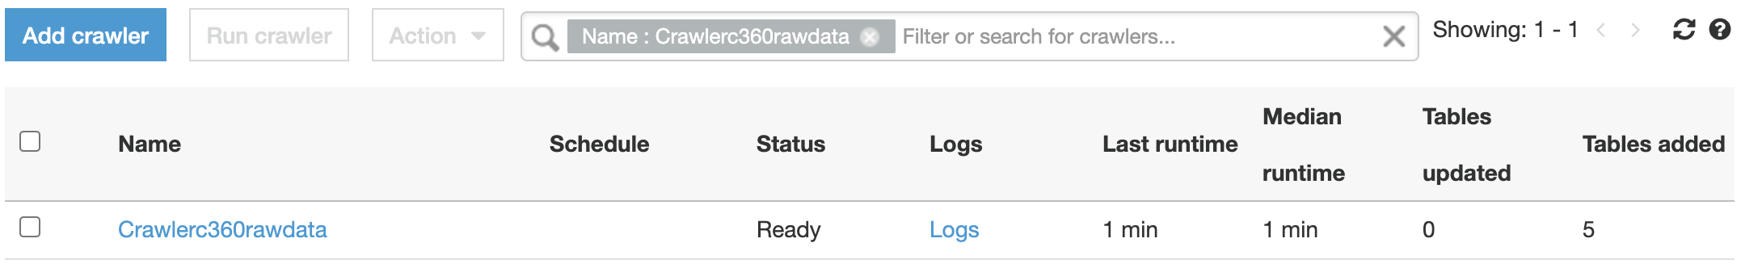

### The crawler creates tables in a database c360view_raw, with different file format, csv, json and relational database tables, that are now in AWS Glue catalog.

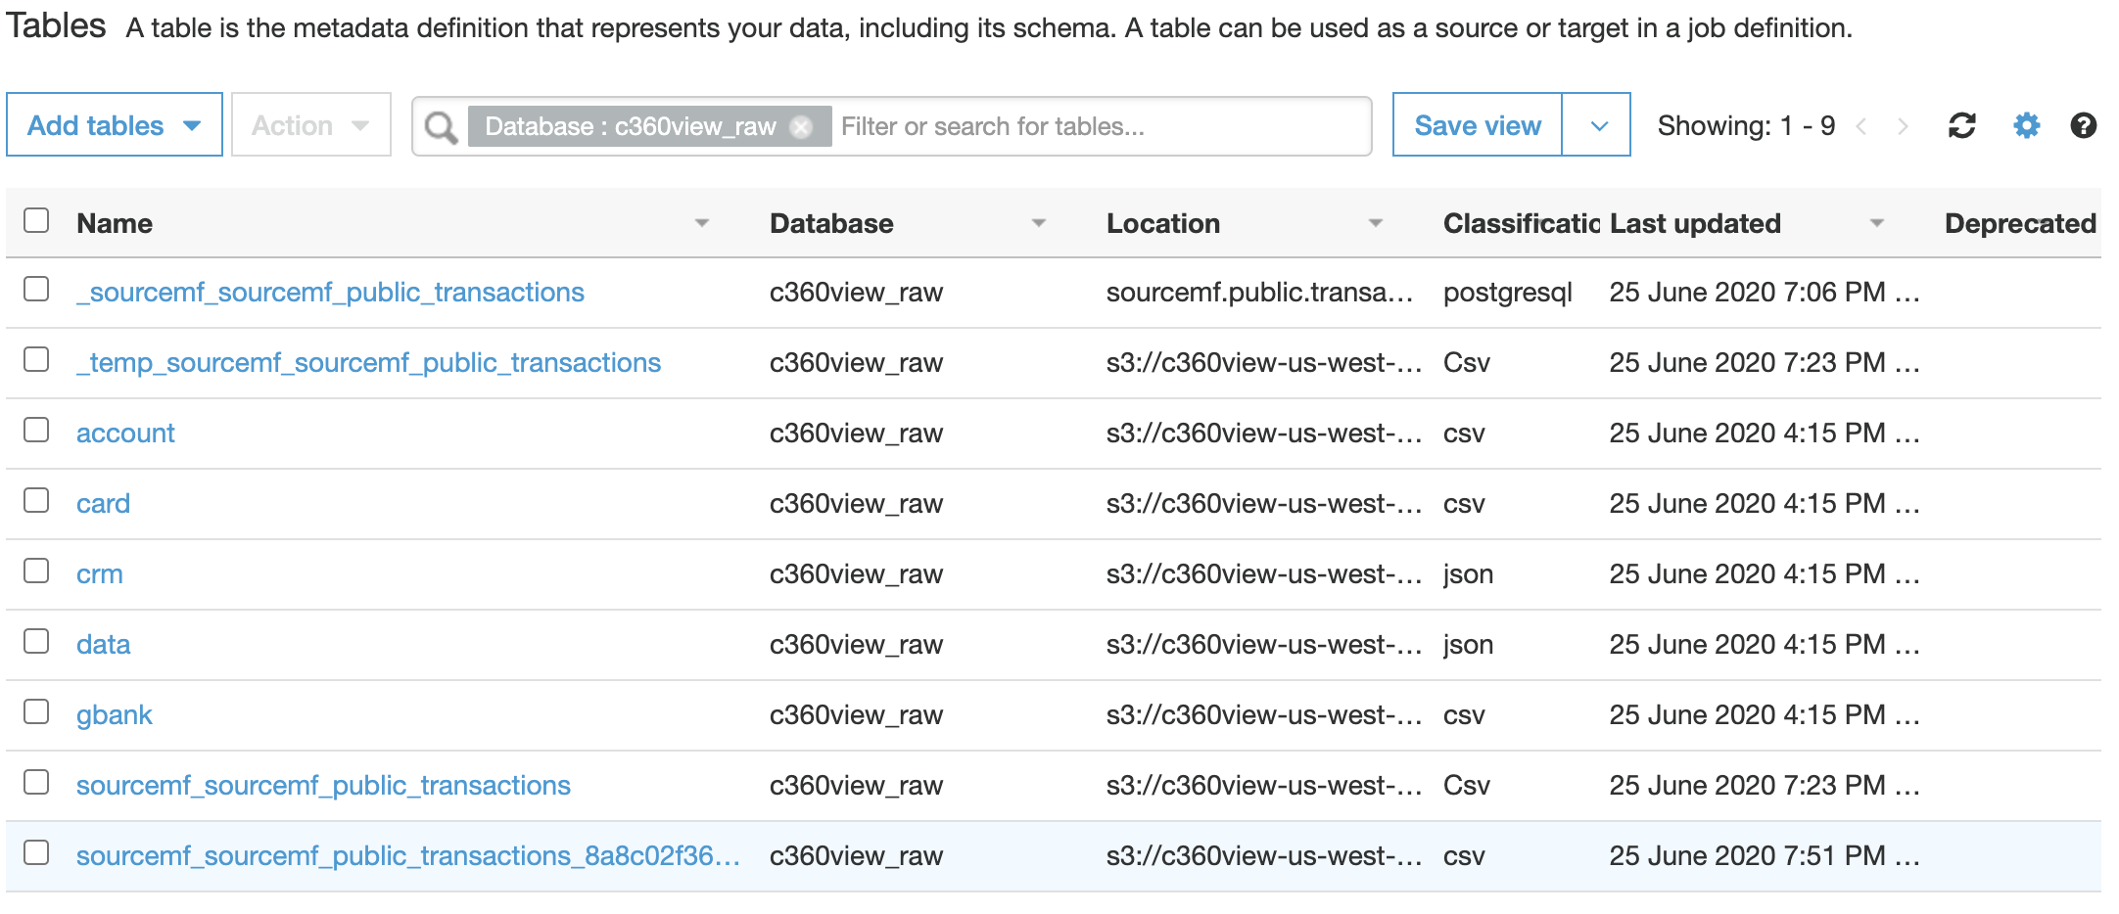

In the table definition we can change table definition such as data type from timestamp to string because it has a different format for some values.

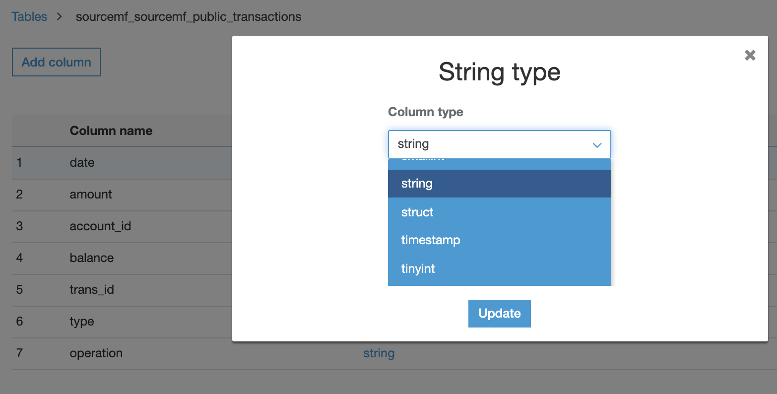

## Perform transformation with source raw tables and to have it flatten and transformed to parquet files.

To orchestrate a set of transformations we are going to use AWS Step Functions state machines, AWS Lambda Functions and Amazon Athena.

We constructed 3 different state machine flows to perform different transformation.

One step function transform GA tables in a flat denormalized table, a second one to transform other RAW data tables into parquet, partitioned tables, and a last one to process and a third one to parse data from relational database raw data.

In this step functions state machine, we are performing transformation for GA tables. GA schema has nested fields that are being flatten using CROSS JOIN UNNEST functions and qualifying nested struct and array data types.

* This state machine uses one lambda function to execute the transformation using Amazon Athena query execution.
* Another lambda function is used to check the termination of the previous query, and then wait or go to next transformation steps.

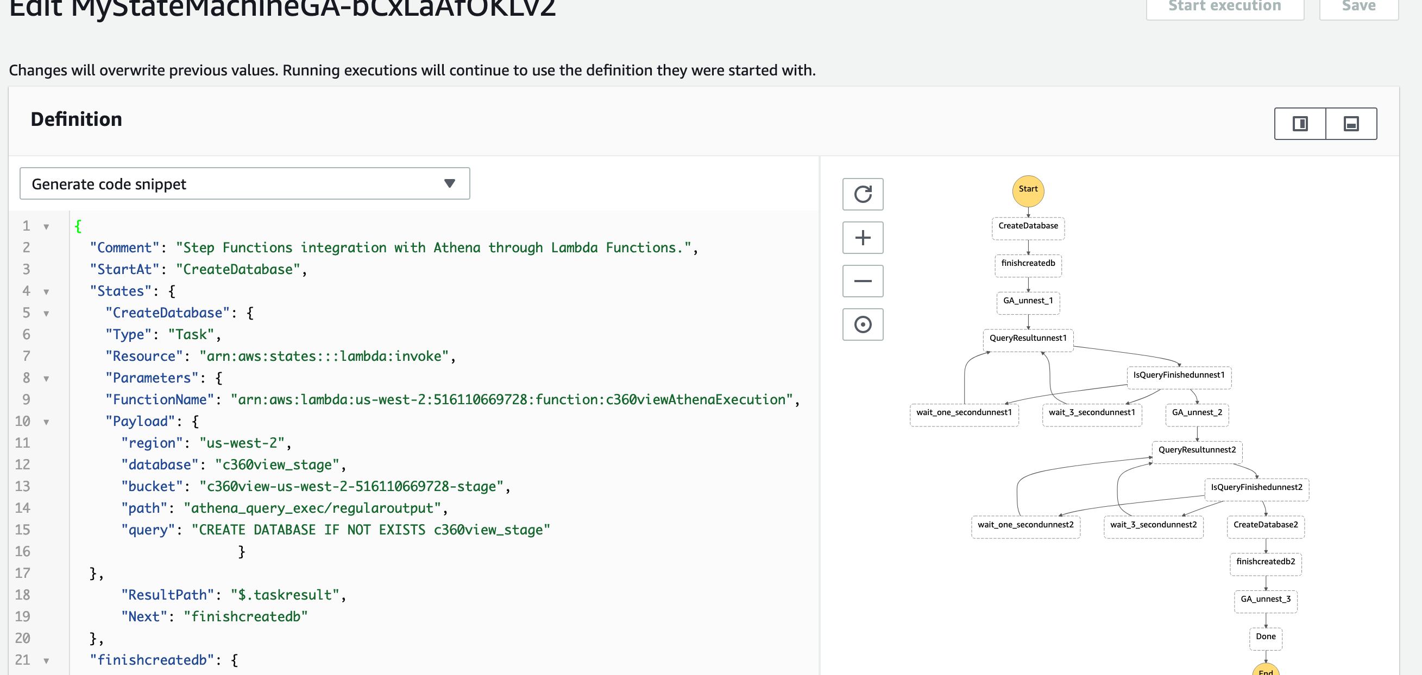

While it runs, we can check the steps it’s performing in our case it’s calling a lambda function to execute queries on Athena.

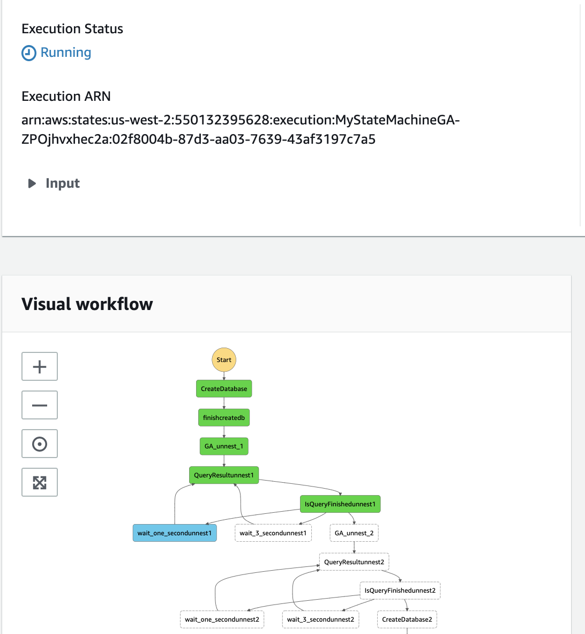

In the second step function we perform the transformation from CSV format to parquet format for the tables gbank (general banking), account and card, and from Json format to parquet format for the customer (CRM) table. We are doing this because handling parquet format tables is faster for joins and group by functions that we need to perform later.

Verify the following workflow to see that in this case we are performing 4 transformation in parallel.

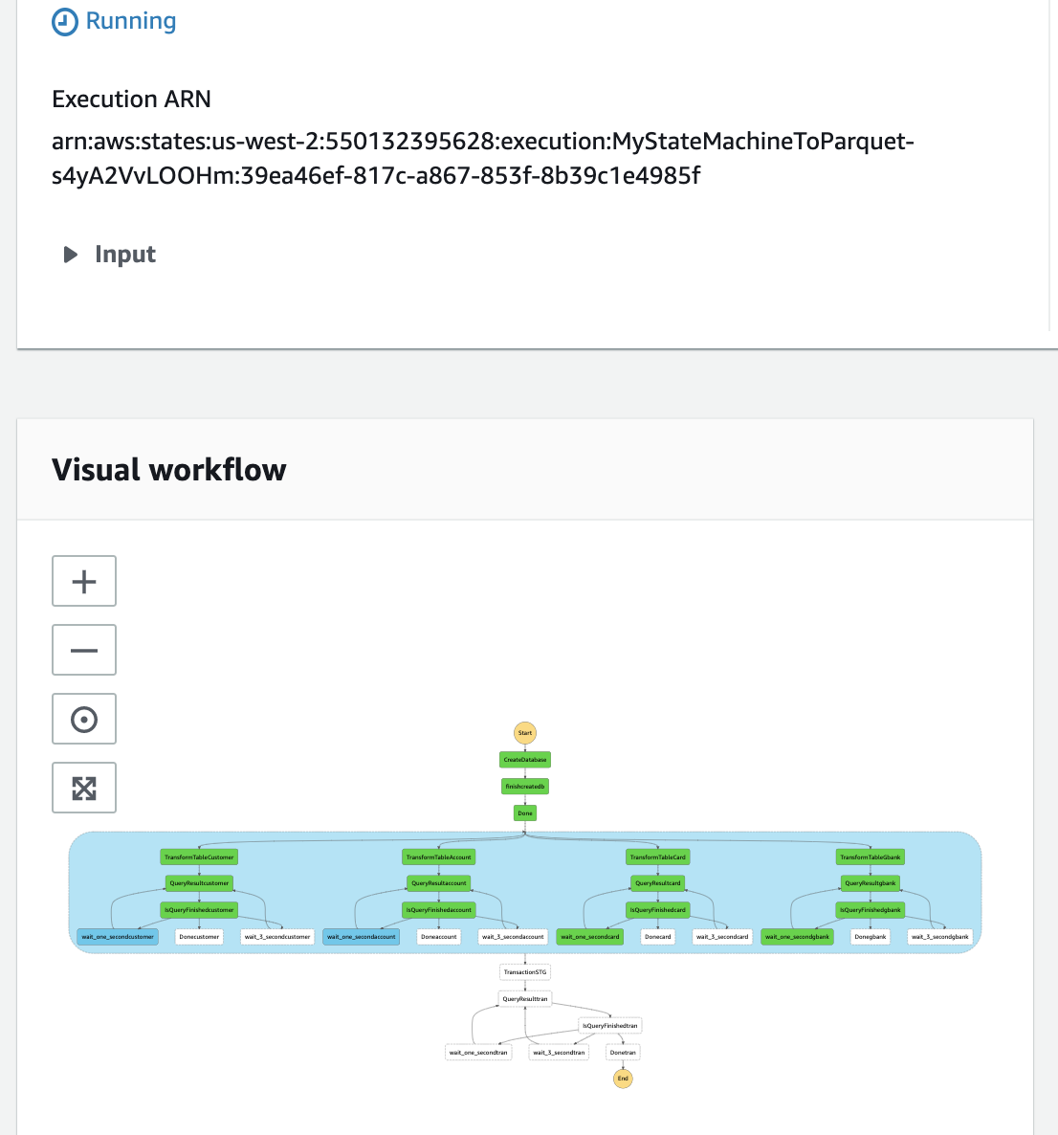

## We use Amazon Athena to query the raw and stage tables.

In Athena console we can see the three databases we created and query the tables created on raw and stage areas.

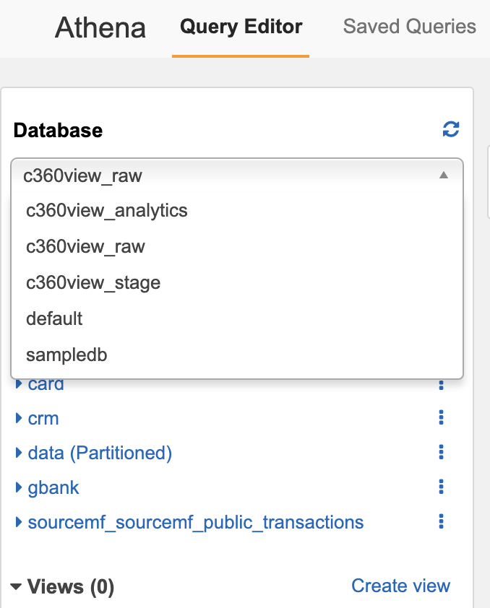

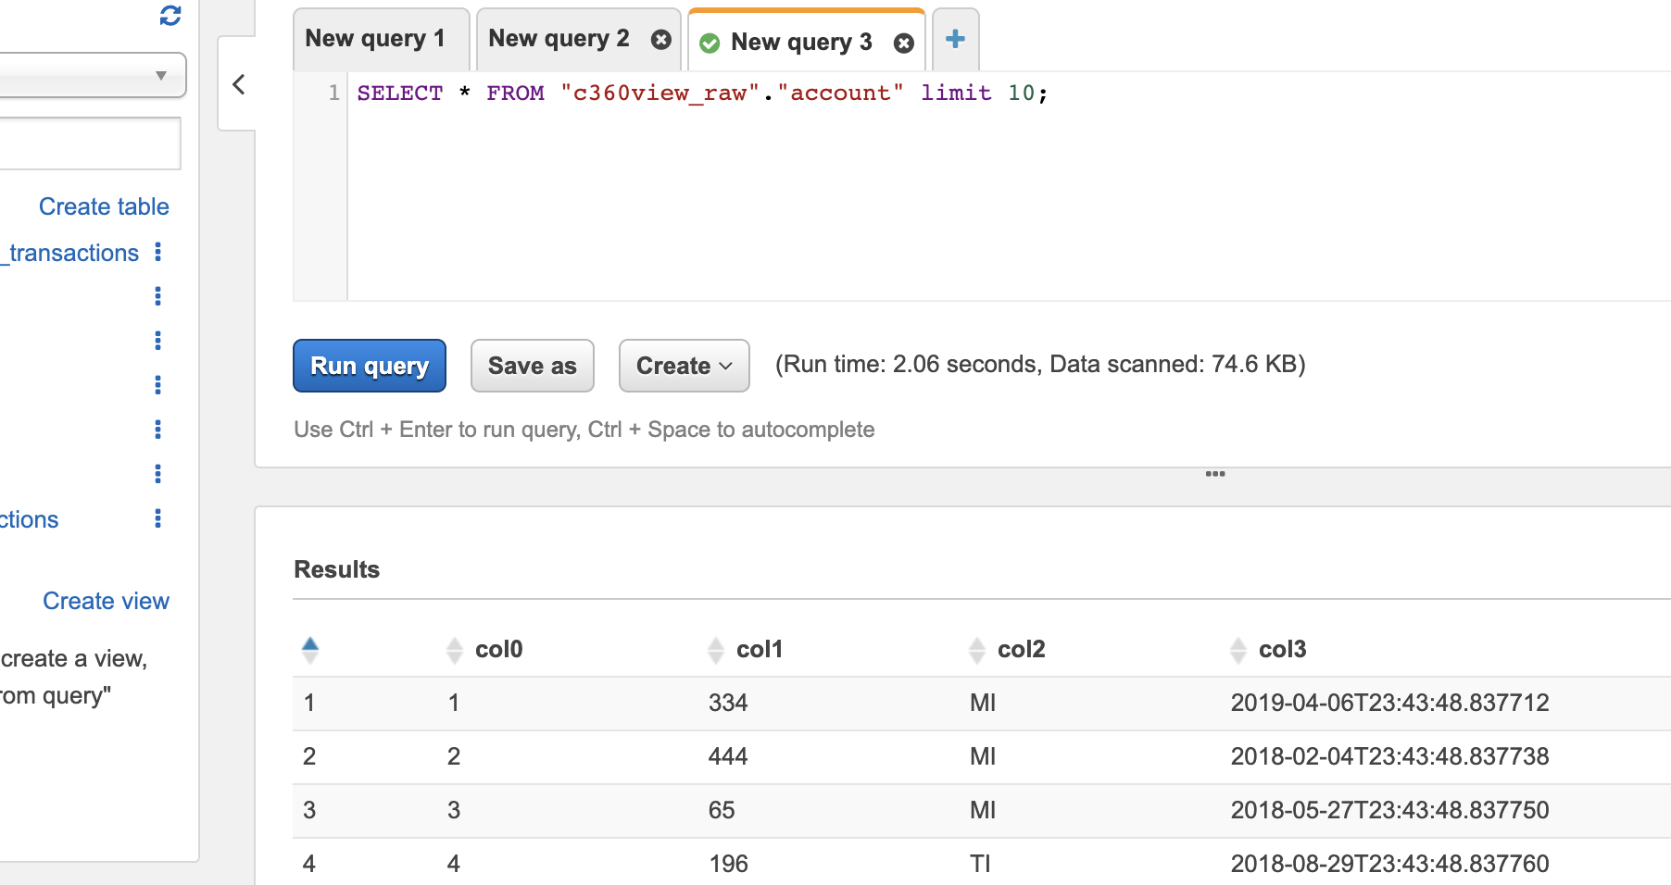

Notice that as we had CSV without header the name of the columns where crawled as col0 to col3 in the RAW data.

We can edit this on AWS Glue, but our jobs to processed the data in Step Functions are already aware of it, so when we go to **c360view_stage** database we find a different scenario.

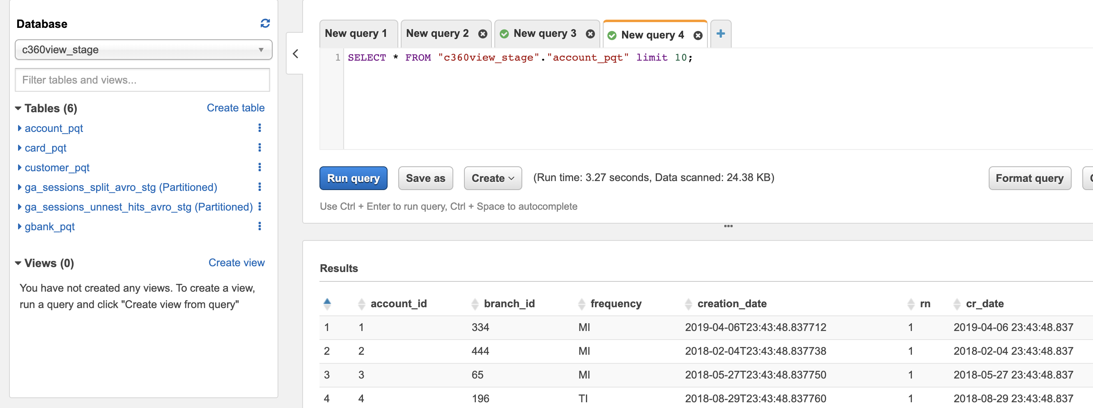

Another example we see in stage is the mf_transactions_pqt parquet format table.

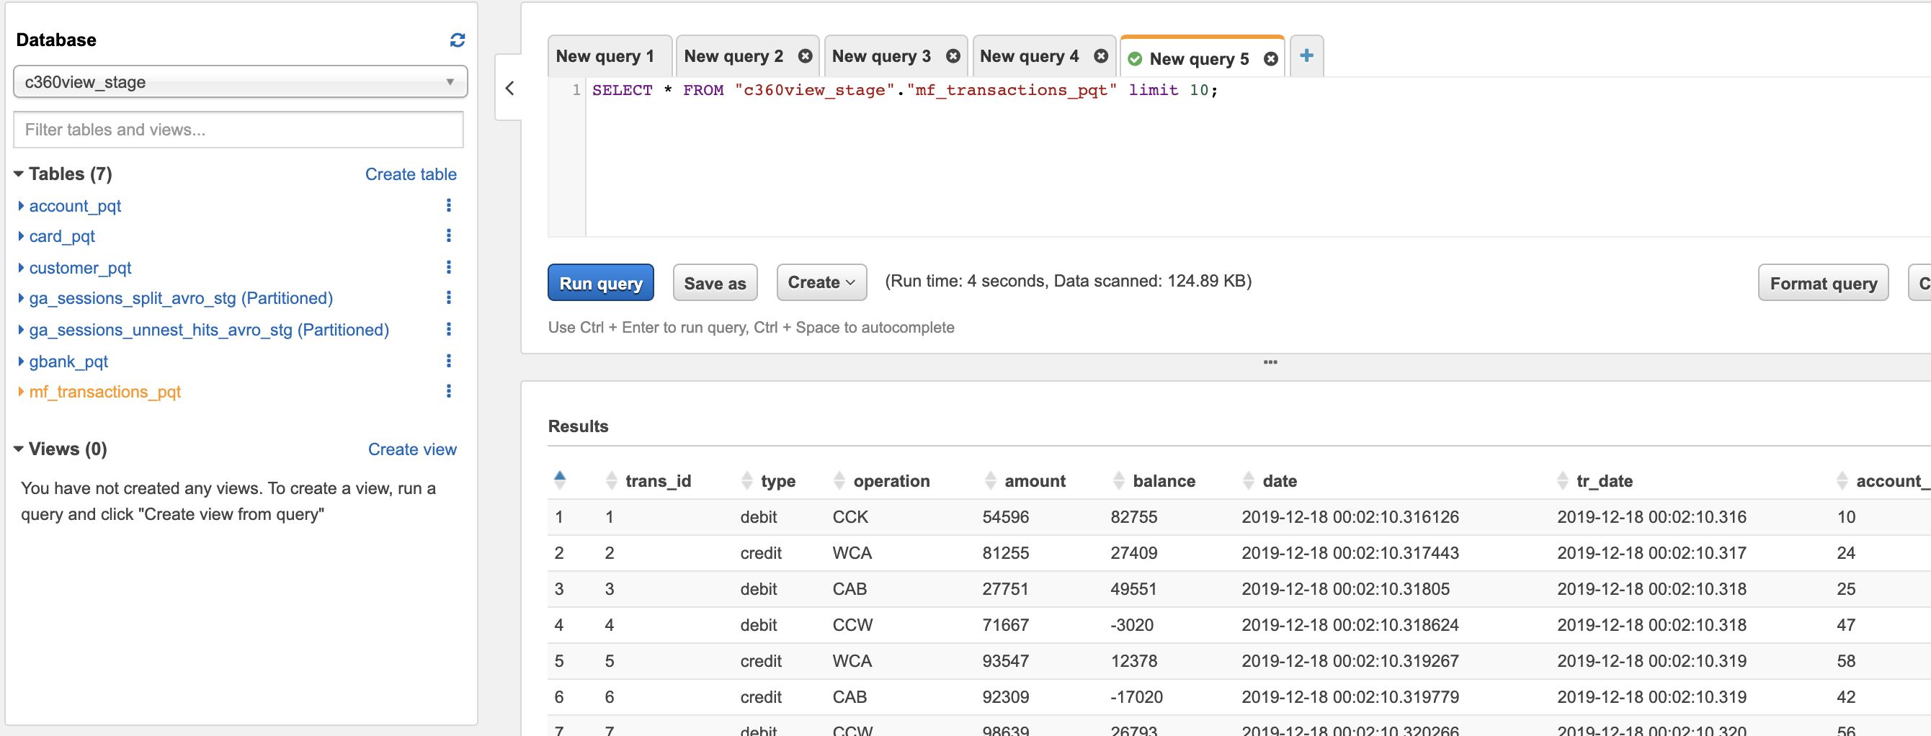

## Now we are going to perform more advanced transformations using AWS Glue job with Pyspark.

## The first job [n1_c360_dispositions](https://github.com/aws-samples/build-a-360-degree-customer-view-with-aws/blob/master/gluejobs/n1_c360_dispositions.py) performs a join between 3 tables, general banking, account and card, to calculate disposition type and acquisition information.

## Notice that in this first Pyspark script converts a query result from Amazon Athena to a Pandas data frame and then the result from Pandas is processed and written to parquet files in Amazon S3 using spark write operation.

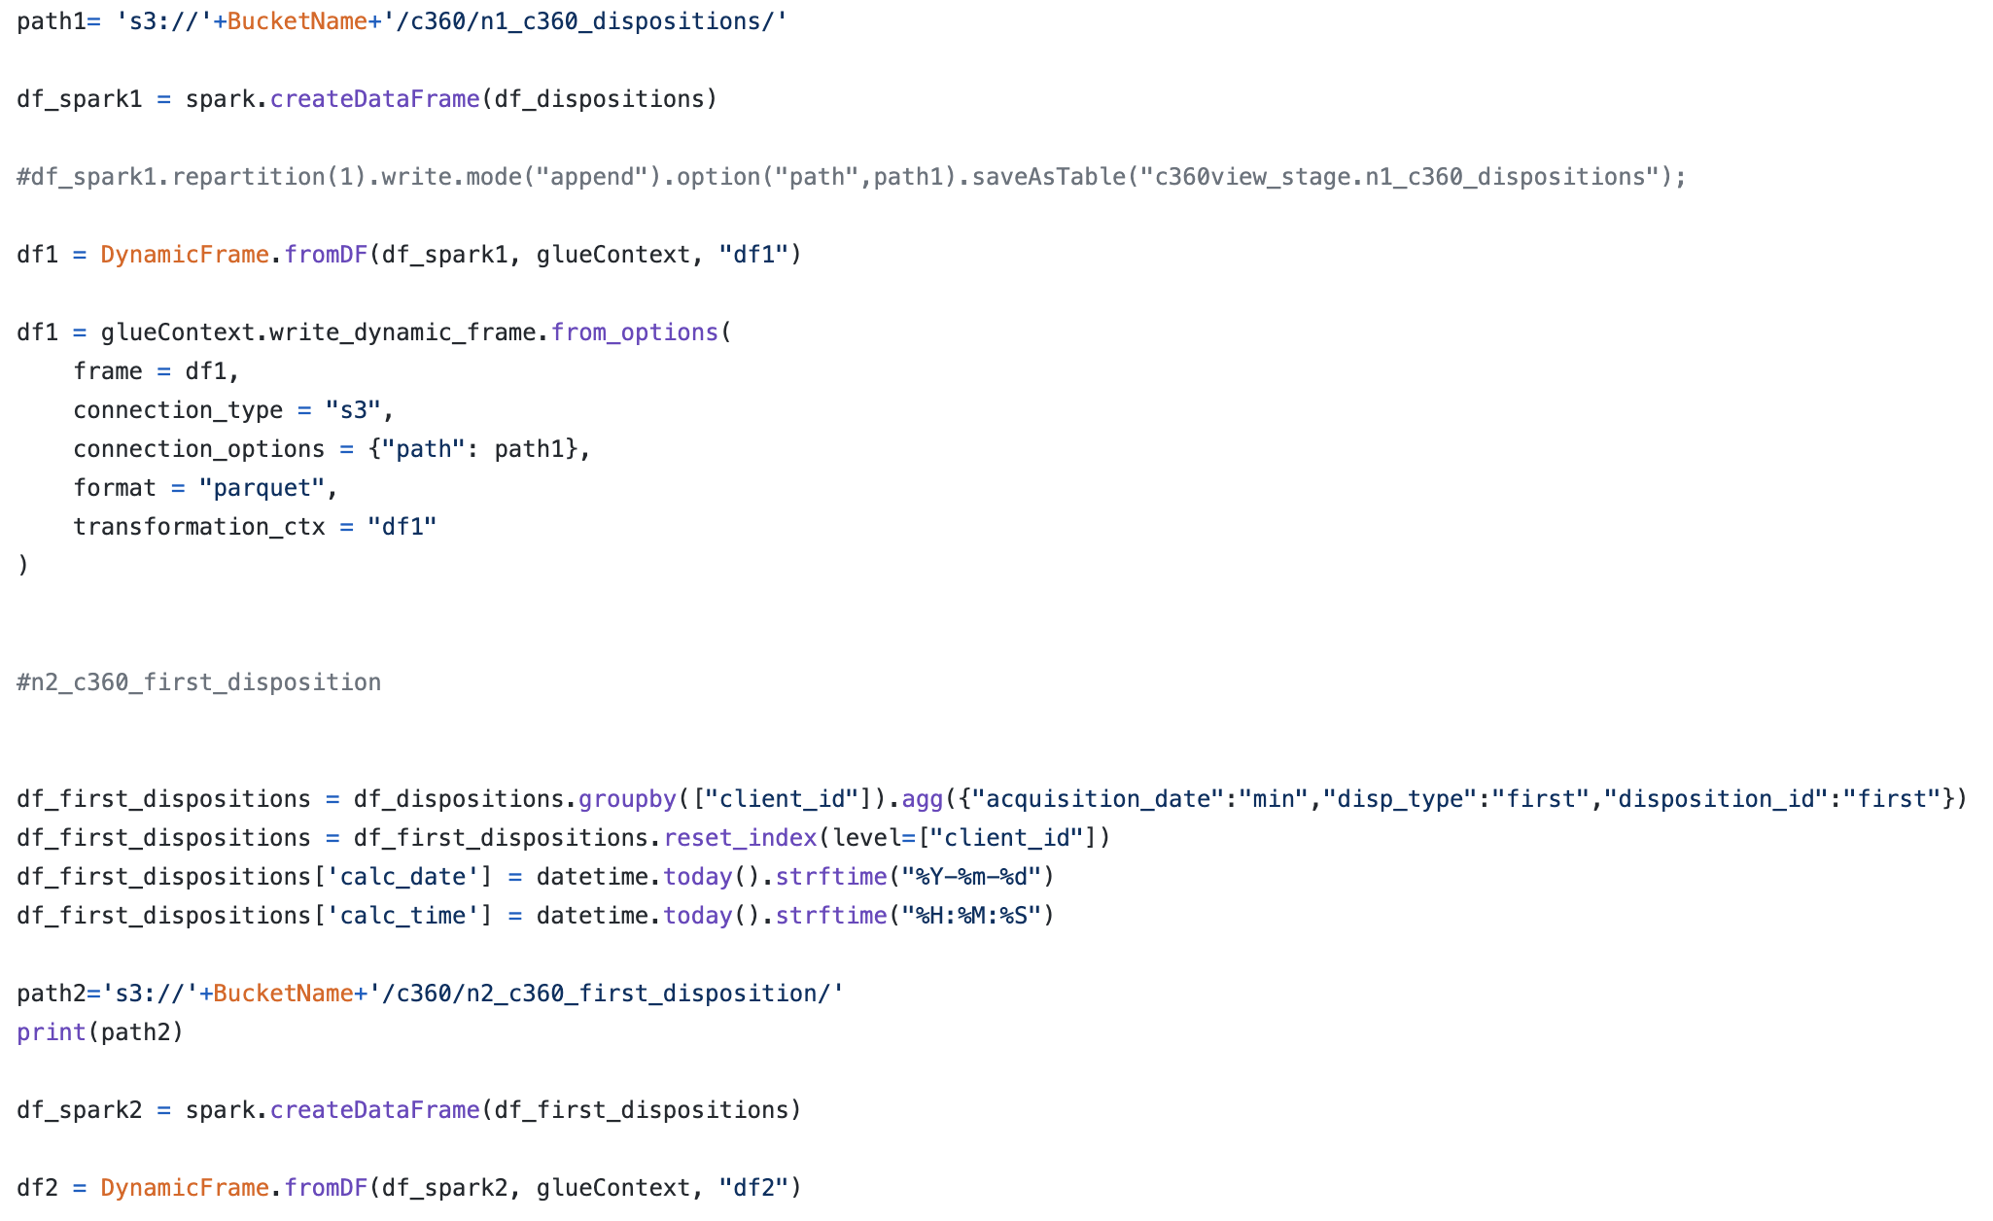

## Then the [Jobcust360etlmftrans](https://github.com/aws-samples/build-a-360-degree-customer-view-with-aws/blob/master/gluejobs/cust360_etl_mf_trans.py), another Pyspark job, we are doing some aggregations with the transactions from relational database done by account_id in the last 3 months and also the last 6 months. For this we used the AWS Glue dynamic frame.

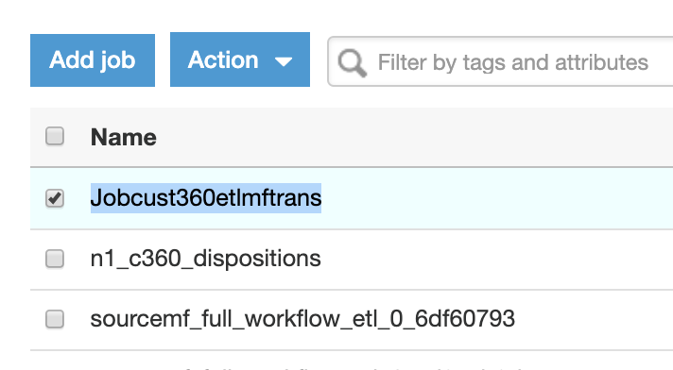

### In this pyspark job we are doing some aggregations with the transactions from relational database done by account_id in the last 3 months and also the last 6 months. For this we used the AWS Glue dynamic frame.

### 

### After these two transformations and running a glue crawler on stage bucket we have now 14 tables in the c360view_stage database.

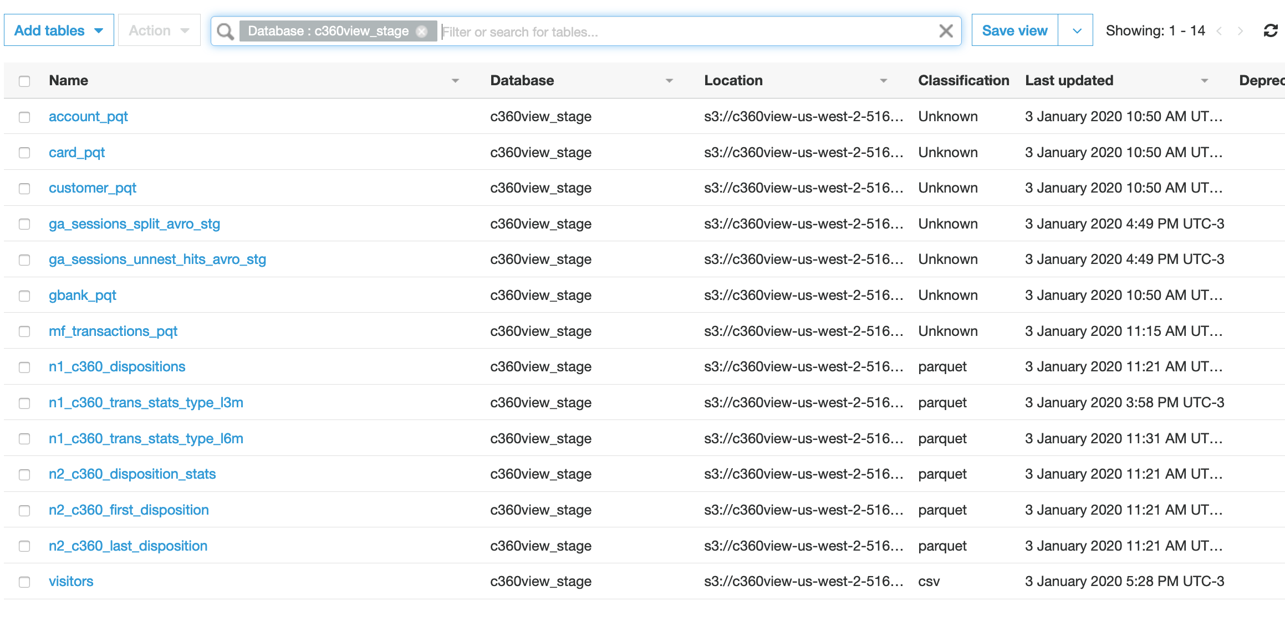

## To create a denormalized table we run spark job on Amazon EMR.

Amazon EMR is a powerful cluster, that you can set with few machines like in this blog to thousands of machines if huge production environment. Consider using spot instances for batch processing and terminate your clusters when you are not using, storing your job results on Amazon S3.

We use an EMR step to submit a Spark SQL application for [denormalization](https://github.com/aws-samples/build-a-360-degree-customer-view-with-aws/blob/master/dynamodb_emr/c360_analytics.py), that performs a set of joins with all Customer dimensions we calculated before to build our final 360 degree customer view table in S3.

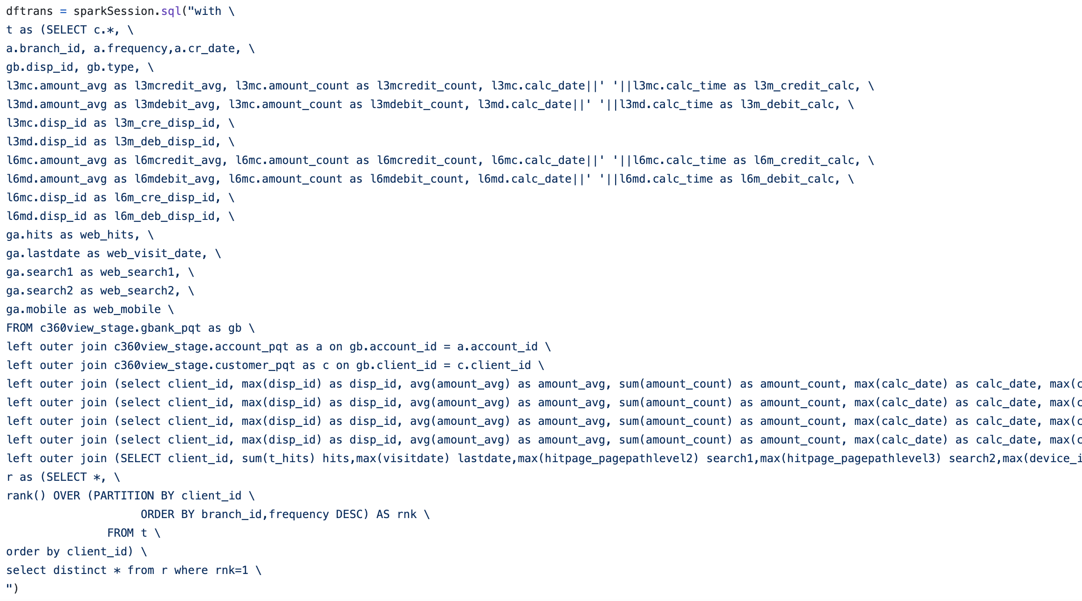

## After completion the job has created a denormalized table in S3 and also the table definition in AWS Glue catalog.

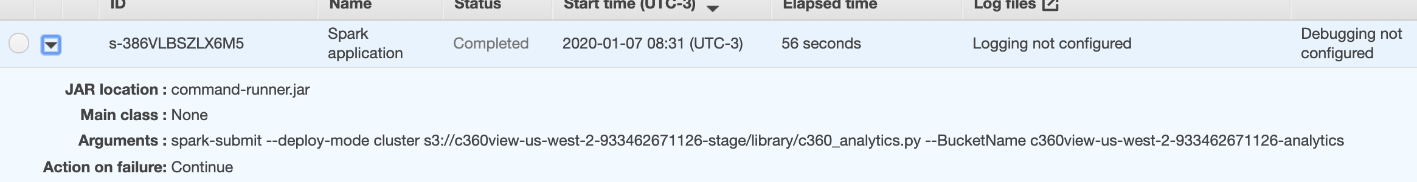

In [Athena console](https://us-west-2.console.aws.amazon.com/athena/home?region=us-west-2#query) we check the new **c360denormalized** table on **c360view_analytics** database.

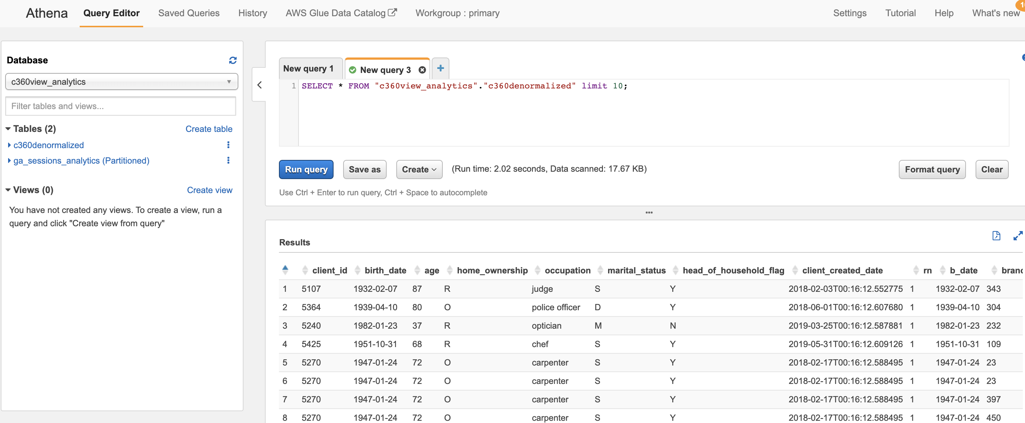

## Finally, we populate the Amazon DynamoDB table with the results to be the source for low latency queries from your applications or APIs.

We use a [Hive script](https://github.com/aws-samples/build-a-360-degree-customer-view-with-aws/blob/master/dynamodb_emr/c360dynamodbload.q) to perform the query on source S3 table and load the data into the DynamoDB table.

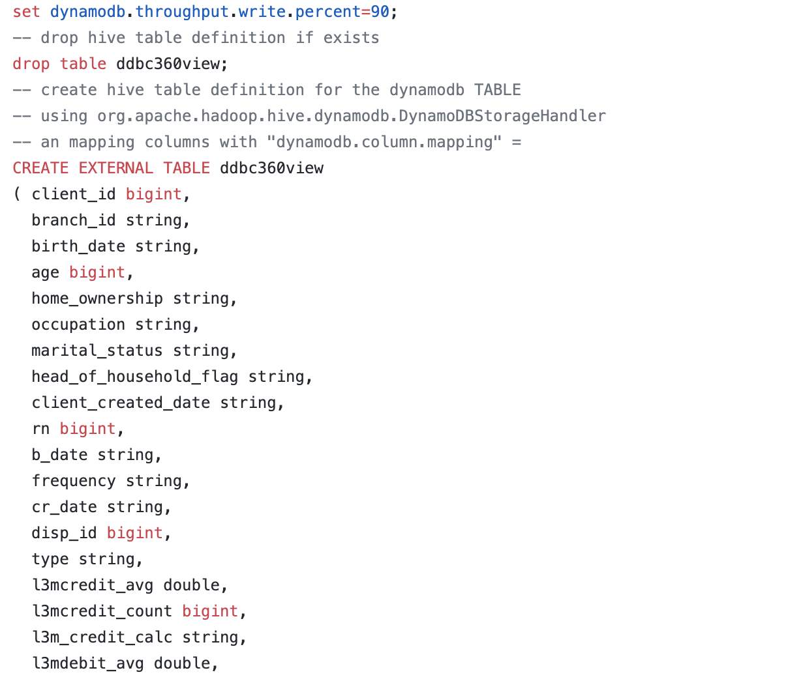

Where we map the fields from the S3 table to DynamoDB table, and then insert the data selecting from our S3 table.

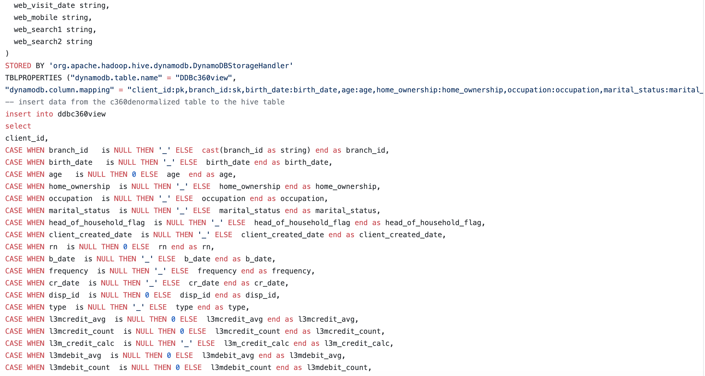

## Now we can query data from Amazon DynamoDB.

In the Dynamodb console we click on the table DDBc360view that we have populated with a Hive script using our EMR cluster.

## 

## Notice that the console did a Scan operation, returning all data, but in your application, you may want to be specific and use a client id or/and branch for example.

So, we take note of some pk (partition key), that is our “client_id” from denormalized table and sk (sort key) that is our “branch_id”, so we can perform some specific query.

In our case, we can use 5002, 5006, 5014, 5021, 5025, 5035… and so on for client id (our pk), and 198, 465, 236, 218, 109, 215, 394, 381, 225 for branch.

Your numbers will be different as the data being generated in your account is random.

Going to the right and down we can check other fields for the records.

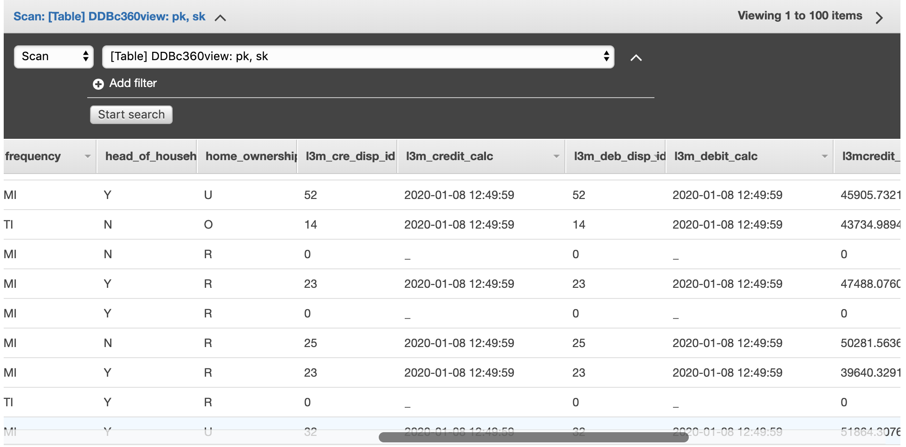

Now instead of Scan, we select Query and put a value of client id in the pk field. In my case 5002, but select one of yours taken in previous step.

When we click on Start search we see that it’s display right away, this is how our production application should look for someone in the DynamoDB table, to pick up in few milliseconds the context for the next interaction we should have with this customer, the status of his last transaction or any other dimension we loaded.

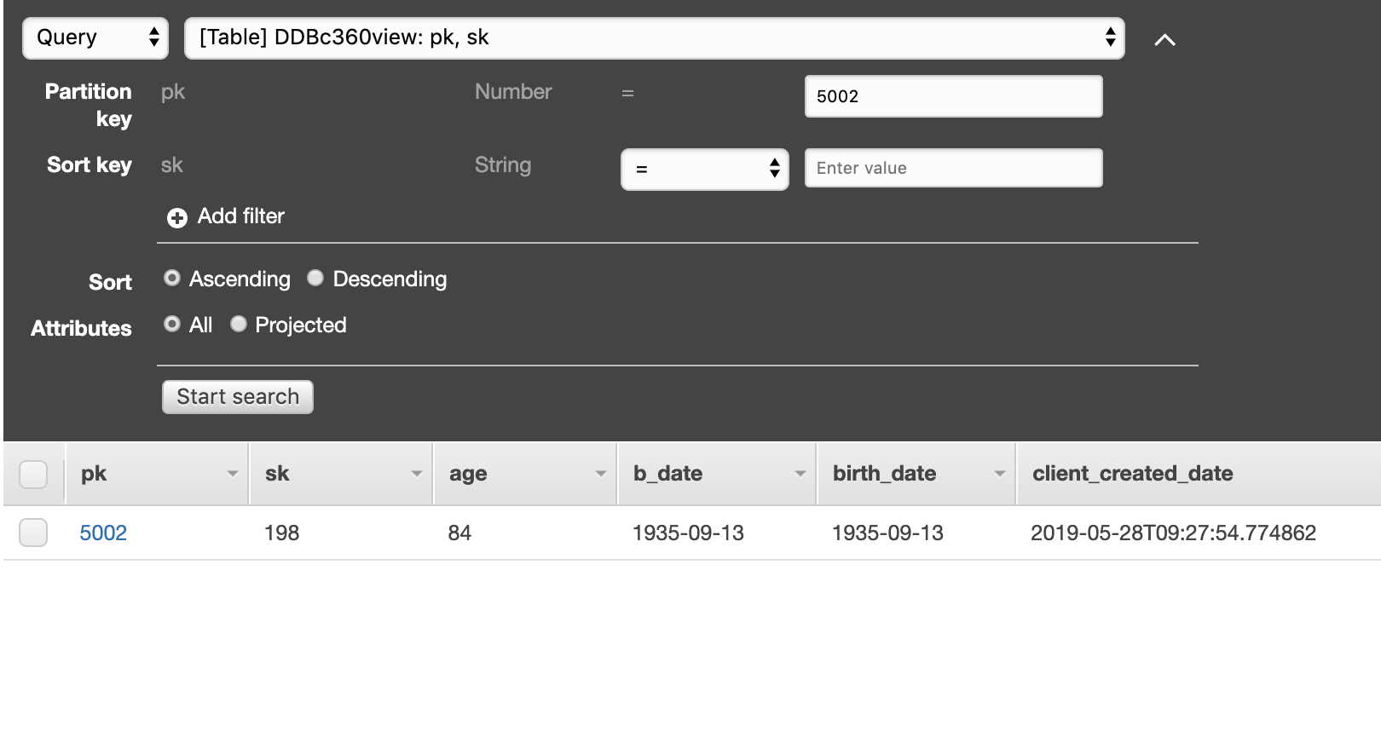

We check the full payload.

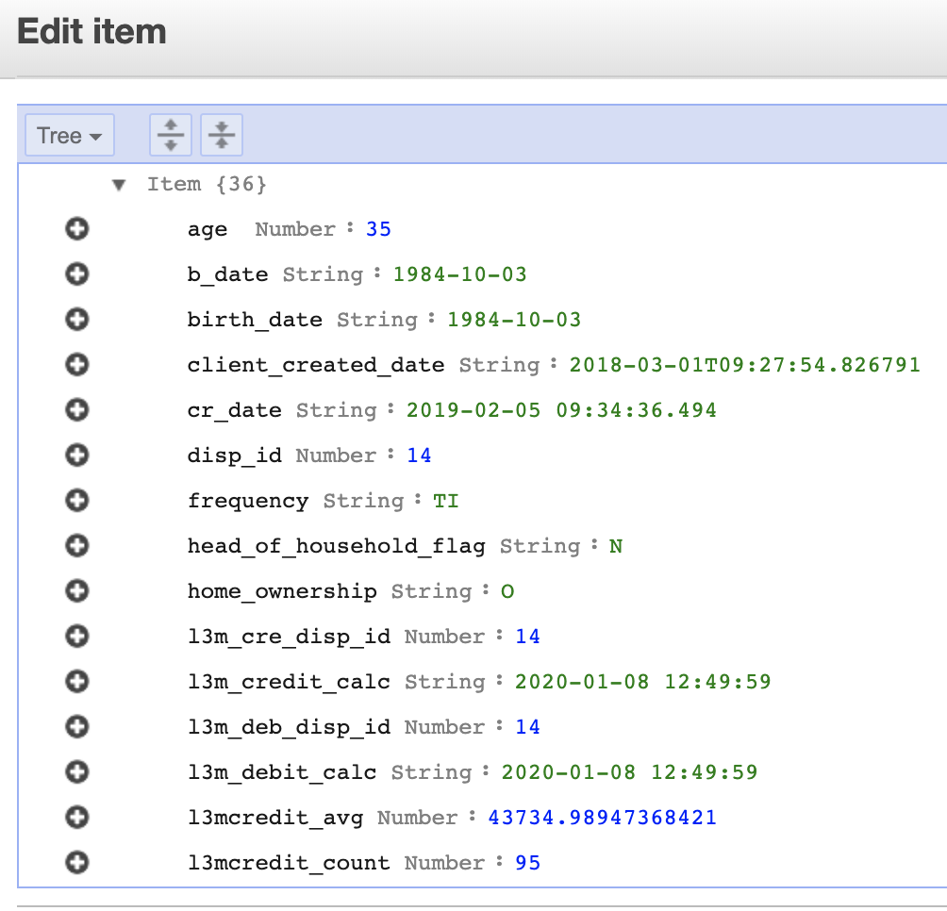

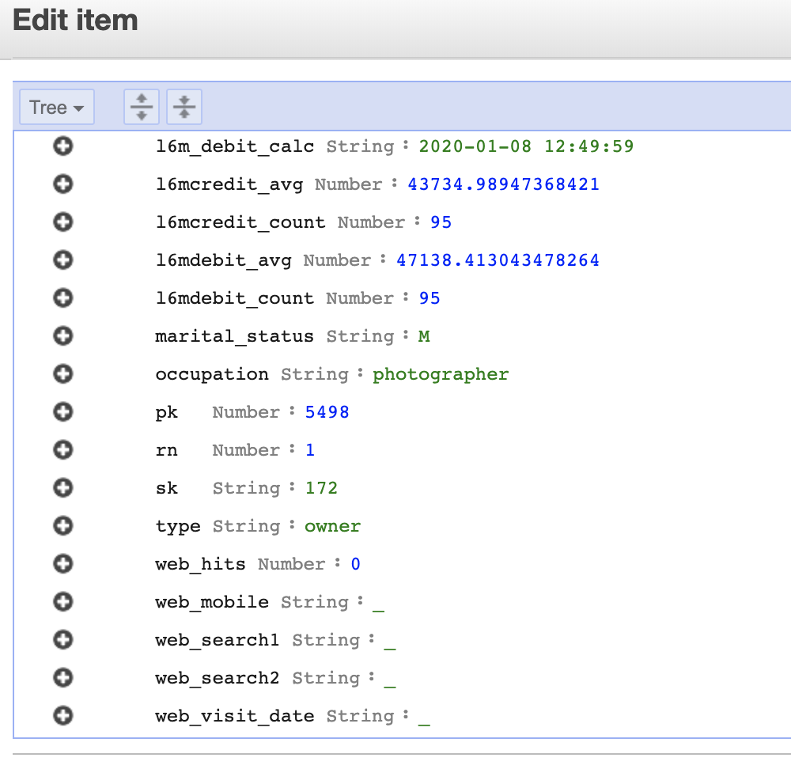

We did a query by partition key; we can also use the index to direct find for every customer in a branch by choosing a Global secondary index.

Using Global secondary index, we can change the query key by other field we need to find data very fast.

We select the GSI1 index to query the table.

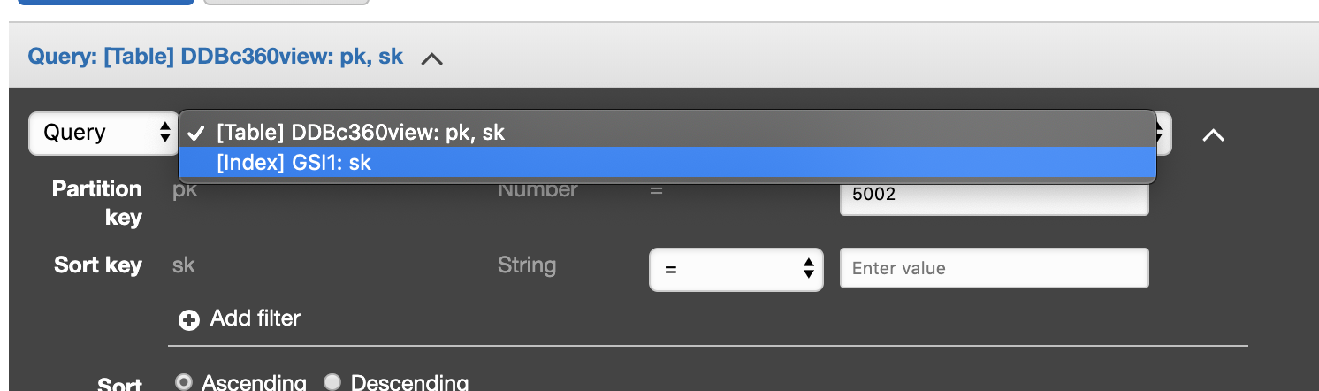

And use a branch number as input, such as 394 in our case to get the result in less then 10 milliseconds.

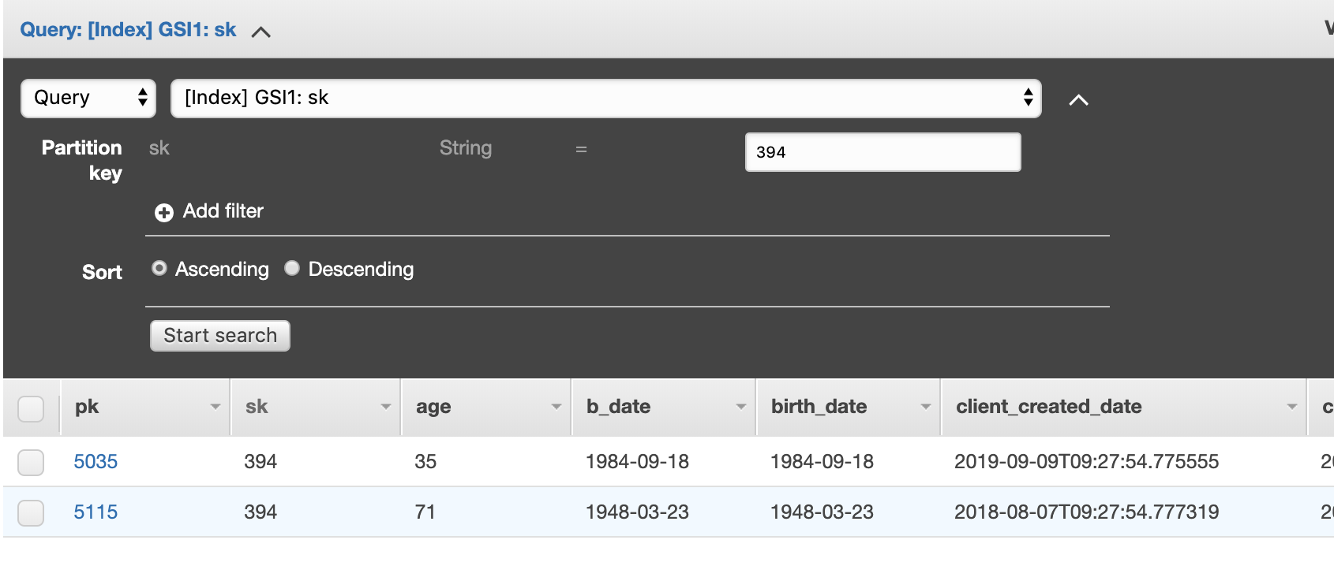

The use case for this Amazon DynamoDB table is to have fast access to data when you need to interact directly with your customer for example your mobile branch manager application, or your contact center application to check the profile or even other dimensions you decide to increment here, like next best offer.

There are several examples to expose a DynamoDB table with an API, using Amazon API Gateway, like [this blog](https://aws.amazon.com/blogs/compute/using-amazon-api-gateway-as-a-proxy-for-dynamodb/), but if your application resides inside your AWS account you probably may use calls directly to [DynamoDB SDK and API](https://docs.aws.amazon.com/amazondynamodb/latest/developerguide/Programming.html).

### For Data scientists and business users, you can also use Amazon Sagemaker and Amazon Quicksight to explore the data using Athena. Find more details on the links for [creating data set from Athena on Quicksight](https://docs.aws.amazon.com/quicksight/latest/user/create-a-data-set-athena.html) and [run SQL queries in Sagemaker](https://aws.amazon.com/blogs/machine-learning/run-sql-queries-from-your-sagemaker-notebooks-using-amazon-athena/).

## Summary

In this blog you have learned a point of view of a 360-degree customer strategy. You have seen the data lake strategy using Amazon S3 and Lake Formation. We have explored some dimension for financial services, but as you follow the processes to bring data sources and the processing tools, it’s easy to add new sources and new calculations.

We have used several AWS services such AWS Lambda functions used to process data using Athena API and Step functions, then AWS Glue for spark and python jobs, and finally the capabilities of Amazon EMR using Spark and Hive to generate the final tables in Data Lake and also on DynamoDB. Check our [git](https://github.com/aws-samples/build-a-360-degree-customer-view-with-aws/blob/master/deployment/README.md) for the code we used and for instructions to deploy it in you account.